- Volume and capacity

1. The figure below shows a bucket of depth 30cm used to fill a cylindrical tank of radius 1.2m and height 1.35m which is initially three-fifth full of water.

30cm
40cm

  - Calculate, in terms of Π;
    - The capacity of the bucket in litres (5mks)
    - The volume of water required to fill the tank in litres (2mks)
    - Calculate the number of buckets that must be drawn to fill the tank (3mks)
2. A bucket is in the shape of a frustum with base radius 12cm and top radius 16cm. The slant height of the bucket is 30cm as shown below. The bucket is full of water.
(a) Calculate the volume of the water. (Take π = 3.142) (6 marks)

16

30

12

(b) All the water is poured into a cylindrical container of circular radius 12cm. If the cylinder has height 45cm, calculate the surface area of the cylinder which is not in contact with water. (4 marks)

3. The British government hired two planes to airlift football fans to South Africa for the World cup tournament. Each plane took 10 ½ hours to reach the destination.
Boeng 747 has carrying capacity of 300 people and consumes fuel at 120 litres per minute. It makes 5 trips at full capacity. Boeng 740 has carrying capacity of 140 people and consumes fuel at 200 litres per minute. It makes 8 trips at full capacity. If the government sponsored the fans one way at the cost of 800 dollars per fan, calculate:
(a) The total number of fans airlifted to South Africa. (2mks)
(b) The total cost of fuel used if one litre costs 0.3 dollars. (4mks)
(c) The total collection in dollars made by each plane. (2mks)
(d) The net profit made by each plane. (2mks)
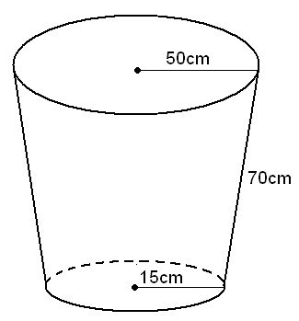
4. The figure below represents a part in form of a frustum of a right circular cover. The upper and the lower radii are 50cm and 15cm respectively. The slant height is 70cm.

a. Calculate the height of the pail. (5 cm)

b. Find the capacity of the pail to the nearest a litre. (5 mks)

5. Consider the vessel below
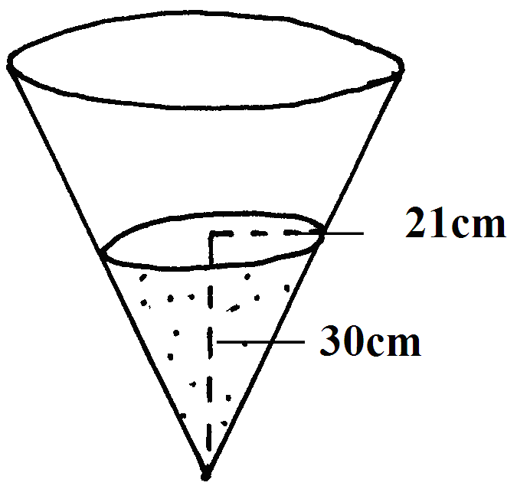
a) Calculate the volume of water in the vessel.
b) When a metallic hemisphere is completely submerged in the water, the level of the water rose by 6cm. Calculate:
i) the radius of the new water surface.
ii) the volume of the metallic hemisphere (to 4 s.f)
iii) the diameter of the hemisphere (10 mks)
6. A village water tank is in the form of a frustrum of a cone of height 3.2m.
The top and bottom radii are 18m and 24m respectively
(a) Calculate:
(i) The surface area of the tank excluding the bottom
(ii) The capacity of the water tank

(b) 15 families each having 15 members use the water tank and each person uses
65 litres of water daily. How long will it take for the full tank to be emptied

7. The diagram below shows a bucket with a top diameter 30cm and bottom diameter 20cm.
The height of the bucket is 28cm
(a) Calculate the capacity of the bucket in litres

30cm
28cm
20cm

(b) Find the area of the metal sheet required to make 100 such buckets taking 10% extra for
overlapping and wastage

8. A rectangular water tank measures 2.6m by 4.8m at the base and has water to a height
of 3.2m. Find the volume of water in litres that is in the tank

9. The figure alongside shows a cone from which a frustum is made. A plane parallel to the base
cuts the cone two thirds way up the vertical height of the cone to form frustum ABCD.
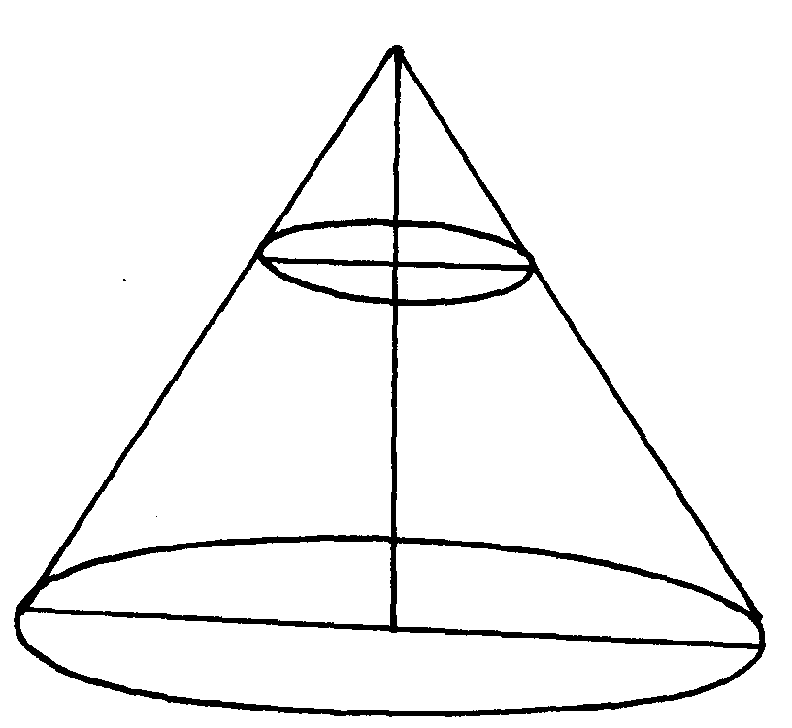
The top surface radius of the frustum is labeled r and the bottom radius is R
V
D
C
Y
B
A
r
x
R

a) Find the ratio r:R
b) Given that r = 7cm, find R
c) If the height VY of the original cone is 45cm, calculate to the nearest whole number the volume
of the frustum
d) The frustum represents a bucket which is used to fill a rectangular tank measuring 1.5m
long, 1.2m wide and 80cm high with water. How many full buckets of water are required
to fill the tank

10. Three litres of water (density1g/cm³) is added to twelve litres of alcohol (density 0.8g/cm³.
What is the density of the mixture?

11. A rectangular tank whose internal dimensions are 2.2m by 1.4m by 1.7m is three fifth full
of milk.
(a) Calculate the volume of milk in litres
(b) The milk is packed in small packets in the shape of a right pyramid with an equilateral
base triangle of sides 10cm. The vertical height of each packet is 13.6cm. Full packets
obtained are sold at shs.30 per packet. Calculate:
(i) The volume in cm³ of each packet to the nearest whole number
(ii) The number of full packets of milk
(iii) The amount of money realized from the sale of milk

12. An 890kg culvert is made of a hollow cylindrical material with outer radius of 76cm and
an inner radius of 64cm. It crosses a road of width 3m, determine the density of the material
used in its construction in Kg/m³ correct to 1 decimal place.

